МЕЖДУНАРОДНЫЙ НАУЧНЫЙ ЖУРНАЛ


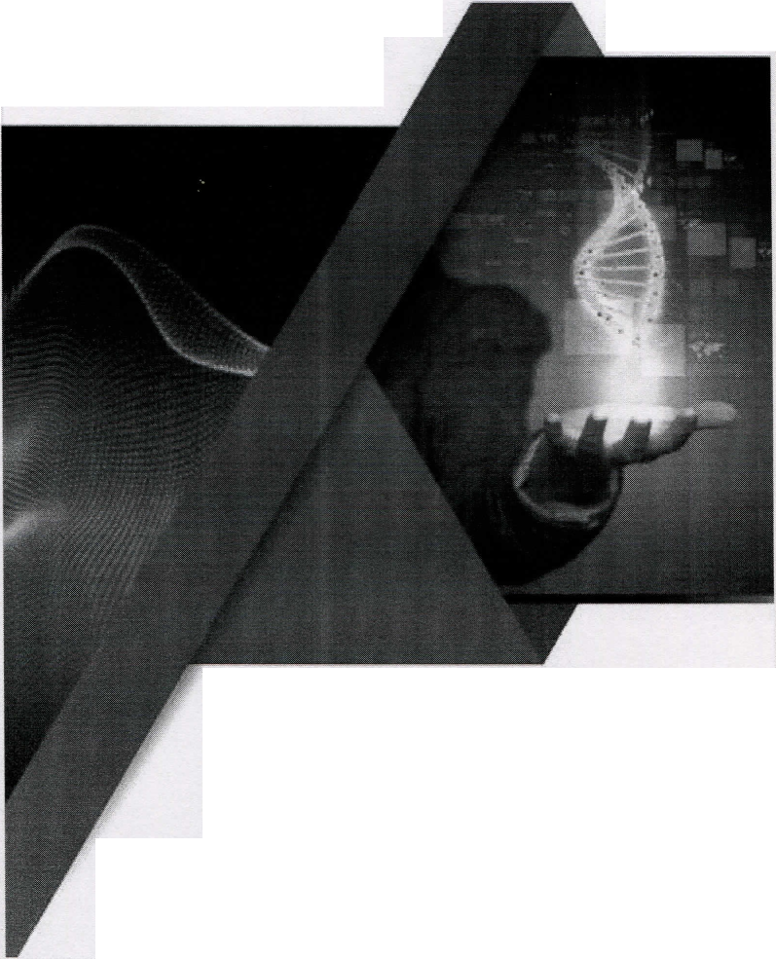
World Science
RS Global
ISSN 241 ЗА 032
Multidisciplinary Scientific Edition
[ISSN print —2413-1032]
[ISSN online — 2414-6404]

DOI: 10.31435/rsglobal_ws
Рецензируемый научный журнал.
Характеристики журнала:
• международный;
- рецензируемый;
- наличие наукометрических баз - Index Copernicus (ICV 2017: 79.17), Google Scholar (h-index - 9); academia.edu
- периодичность издания - ежемесячно;
- открытый доступ к статьям (CC-BY license);
- зарегистрирован в Польше
Выходные данные журнала: / World Science /Warsaw: RS Global Sp. z O.O.

APPLICATION OF THE LASER-CORRELATIVE
SPECTROSCOPY METHOD FOR ASSESSING THE QUALITY
OF PROSTHETICS BY REMOVABLE DENTURES
Shuturminskiy V. G., Maksimenko P. V., Atmazhov I. D.
Ukraine, Odessa, International Humanitarian University
Abstract. The purpose of the study: to analysis the patterns of homeostasis of the oral cavity with the help of a method that allows using an oral liquid with a minimum quantity for the comprehensive assessment of the condition of homeostasis in the oral cavity as a criterion for the quality of dental orthopedic treatment.
Materials and methods: The study was conducted in patients of 2 groups with partial acrylic removable dentures 6 months after treatment: 1-a - without complaints, 2-a - with complaints about the quality of the dentures. Taking oral fluids was performed on the nose with a single-use special pipette. The oral fluid was placed in an epindorph test tube and frozen. The research was carried out using a special apparatus and methods which was described earlier. The analysis of classified LC- spectra of the oral liquid can detect 9 semiotic groups of shifts in 7 directions, which can be identified in three degrees of expressiveness.
Results: The complex study of patients with complications of treatment with removable laminar dentures found a significant discrepancy between objectively detected signs of abnormalities in the oral mucosa and the ultimate effectiveness of the prosthesis.
The results of LCS investigations can establish the possible cause of the established discrepancy: in patients with complications (3-4 times more than in the uncomplicated population) are variants of weakened control of processes of tissue differentiation in the prosthetic area, which significantly complicates the process of adaptation of the mucous membrane to the use of removable dentures.
Conclusion: Based on the developed objective test, we can say that removable acrylic dentures have a negative effect on the periodontal tissue even when the patient complains about the quality of the treatment. Bioengineering plastics were better used for re-prosthetics.
Keywords: polymethylmethacrylate, combined dentures, polypropylene, adaptation, LC- spectroscopy, partial removable denture
Actuality of topic. Modem orthopedic stomatology requires objective tests to determine the quality of prosthetics. It can be explained of transferring the orthopedic dentistry to the principles of evidence-based medicine, the improvement of the Protocols for the implementation of manipulations [1, 2]. Existing diagnostic methods allow to evaluate only one specific criterion of homeostasis of the oral cavity, are rather cumbersome or difficult to execute. The most difficult problem of diagnosis of pathological conditions in dentistry is found in assessing the quality of prosthetics [3].
In modem practice of orthopedic dentistry doctors often face the problem of assessing the quality of prosthetics, which would allow an objective assessment of the performed orthopedic treatment, taking into account not only the accuracy and quality of the clinical and laboratory stages of the prosthesis, but also the perception of a removable dentures by the tissues of the oral cavity and adaptation to the patient.
That is why we set the goal to study the patterns of homeostasis in the oral cavity with the help of a method that allows using an oral fluid with a minimum quantity for a comprehensive assessment of the state of homeostasis of the oral cavity as a criterion for the quality of dental orthopedic prosthesis.
These requirements are corresponded with the method of laser-correlation spectroscopy (LCS) [4], which is quite common in medical research.
Materials and methods of research. Taking oral liquid was performed with a single-use special pipette. The oral liquid was placed in an ependorph test tube and frozen. The researches were carried out using a special apparatus and a technique which was described earlier [5]. The analysis of classified LC-spectra of the oral fluid allows to identify 9 semiotic groups of shifts in 7 directions, which can be identified in three degrees of expression (Table 1), that is, in general, 23 spectrum options are established. It should be noted that this problem is solved automatically using a laser spectrometer and classification programs, which greatly simplifies the technique of complex analysis of homeostasis of the oral cavity [6]. These conditions due to compare with other methods of indicating the nature of tissue homeostasis, which are traditional for orthopedic dentistry, quite convincingly prove the benefits of the approach of the tested method.
The results of the studying and their discussing. The table 1 shows the results of the analysis of LC-spectra of the oral fluid taked in 61 patients who were satisfied with the quality of the prosthesis with partial removable acrylic dentures.
Table 1. Distribution of LC-spectra of oral fluid taked from patients satisfied with removable prosthesis (n = 61), persons, %
Groups | Degree of expressiveness, persons |  |  |  | Total
of shifts | Starting | Medium | Expressed | Number | %
0 - norm |  |  |  | 10 | 16
1 - allergy | 2 | - | 1 | 3 | 5
2 - intoxication | 2 | 3 | 1 | 6 | 10
3 — dystrophy | 3 | 3 | 5 | 11 | 18
4 - autoimmune processes | 3 | 4 | 10 | 17 | 28
5 — catabolic processes | 1 | 2 | - | 3 | 5
6 - allergic + intoxication processes | 1 | - | - | 1 | 1,5
7 - allergic + autoimmune processes | 1 | - | - | 1 | 1,5
8 - dystrophy + autoimmune processes | 9 |  |  | 9 | 15
Total | 32 | 12 | 17 | 61 | 100

According to the data of the table 1, only in 16 % of cases (0-group) recorded so-called normologically- similar spectra. It follows that in 84 % of observations, the method of LCS records one or another homeostatic changes, which indicate the presence of pathological changes in the tissues of the oral cavity in the presence of removable dentures in the oral cavity, even without complications. Proceeding from the literature [7], without prosthetics with the presence of middle defects in the dentition, normal logical-like spectra are observed in 40-45 % of cases.
Based on the proposed discussions of the semiotic classification of LCS biological liquids, biological risk can be determined for different semiotically modified groups. So, when verifying the 3rd group, the disorientation processes in the tissue homeostasis are defined as extremely dystrophic - directed, which prognoses the possibility of atopic forms of stomatitis.
In the same direction, however, with a less pronounced response, intoxication-directed (2-g group) and catabolic-directed (5-th group) variants are interpreted.
While verifying the 4th group, the dysrégulation processes are directed to autoimmune proliferation. In the same direction, but less pronounced the variants which are identified in the 1 st semiotic-cluster group are predicted. Variants that have fallen to the 6, 7, 8th semiotically groups determine markedly weakened differentiation control, which predicts the greatest invariance of issue- changed processes (eg, fibrous).
From all these information we can see that mostly in the examined group of patients, autoimmune hyperproliferations (28 %) and atopic variants of disregulation (28 %) are predicted. While less (in 15 %), complicated tissue transformations are predicted. In other directions, variants are found at a significantly lower frequency (from 1 to 5 %).
In table 2 is presented a comparison of variants of semiotic shifts in the examination of patients. Immediately noticeable deviation from the normological group towards the groups of dystrophic and autoimmune processes. The main difference between them is evident in the 1 st and 8 th semiotic clutch groups: when clinically expressed, the frequency of registration of mixed dysregulatory states, which predict tissue-changed processes, is reduced.
According to published researches, with the difficultés of prosthetics the removable laminar dentures increases the proportion of so-called "psychogenic intolerance of dentures", in which the main clinical complex of symptoms includes expressed subjective complaints, and on the prosthetic area, the symptoms of the allergic-intoxication inflammatory process are extremely weakly visible [8]. From these positions, our results do not indicate the presence of pathology, because tissue-changed processes are rarely accompanied by marked signs of inflammation. On the other hand the complications of prosthetics with removable dentures are often accompanied by neurotrophic disorders [12].
Table 2. Distribution of LC-spectra of oral fluid taked from patients, who have complains to removable prosthesis after 6 months after position their dentures (n=37), persons, %
Groups | Degree of expressiveness, persons |  |  |  |  | Total
of shifts | Starting |  | Medium | Expressed | Number | %
0 - norm | 3 |  | - | - | 3 | 8
1 - allergy | - |  | - | 1 | 1 | 3
2 - intoxication | 2 |  | - | 1 | 3 | 8
3 - dystrophy | 1 |  | 2 | 4 | 7 | 19
4 - autoimmune processes | 2 |  | 4 | 5 | 11 | 30
5 — catabolic processes | 1 |  | 2 | - | 3 | 8
6 - allergic + intoxication processes | - |  | - | - | - | 0
7 - allergic + autoimmune processes | 1 |  | - | - | 1 | 2
8 - dystrophy + autoimmune processes | 8 |  | - | - | 8 | 22
Total | 18 |  | 8 |  | 37 | 100

That is why this situation is recorded in our studies, that totally the huge work of sanogenetic mechanisms of homeostasis regarding the obstruction of the pathological formation.
Some part of variants of the prosthesis intolerance is considered temporary only because the prosthetic area does not show active processes of inflammation.
The table 3 shows the results of LC-spectra of semiotic groups after re-prosthetics, which was agreed upon by 25 patients from a group of people who have shown complaints about the quality of the previous prosthesis. For re-prosthetics we chose combined polypropylene prostheses. The choice was done because of the bio-inertness of this type of prosthesis and easier adaptation to this type of dentures.
Table 3. Distribution of results of LCS in semiotic groups after repeated prosthetics by combined polypropylene / acrylic removable dentures (n = 25), persons, %
Groups | Degree of expressiveness, persons |  |  |  |  | Total
of shifts | Starting |  | Medium | Expressed | Number | %
0 - norm | 7 |  |  | „ | 7 | 28
1 - allergy | 2 |  | - | - | 2 | 8
2 - intoxication | - |  | 3 | - | 3 | 12
3 - dystrophy | 2 |  | 1 | 1 | 4 | 16
4 - autoimmune processes | 1 |  | - | 5 | 6 | 24
5 - catabolic processes | - |  | 1 | - | 1 | 4
6 - allergic + intoxication processes | 1 |  | - | - | 1 | 4
7 - allergic + autoimmune processes | - |  | - | - | - | 0
8 — dystrophy + autoimmune processes | 1 |  |  | . - ■ | 1 | 4
Total | 14 |  | 5 | 6 | 25 | 100

As it is showed in the table 3, the per cent of normal changes is 28 %, that is more for 3, 4 than before the re-prosthetics.
It should be noted that the described character of the group of studied patients signs of inflammatory reactions significantly contrasts with the results of general clinical findings that determine the final effectiveness of prosthetics.
Conclusions. The complex study of patients with complications of prosthesis with removable laminar dentures signed us a significant discrepancy between objectively detected abnormalities in the oral mucosa and the final effectiveness of the prosthesis.
The results of LCS studies can establish the possible cause of the discrepancy: in patients with complications (3-4 times intensive than in the uncomplicated group) there are noticed some variants of weakened control of processes of tissue differentiation in the prosthetic area, which significantly complicates the process of adaptation of the mucous membrane to the use of removable dentures.
At the same time, a clearer argument of the validity of the proposed positions can be made only by considering with dynamic LCS-observations, because only in such variant can be an objective assessment of the functional possibility of dynamic tissue homeostasis.
The volume of these studies is not so significant as to critically substantiate the criterial estimates of the potencies of tissue dynamic homeostasis. At the same time, the sterted stages of dynamic research extent perspective the same directions in the construction of an objective assessment, in which an important practical result can be achieved: personification of prosthetic methods for achieve optimal perception of dentures.
REFERENCES
- Raittio E, Inequality in oral health-related quality of life before and after a major subsidization reform / Raittio E, Lahti S, Kiiskinen U, Helminen S, Aromaa A, Suominen AL. // Eur J Oral Sci. 2015 Aug. - 123(4). - C. 267-75.
- Determinants of the utilization of dental services in a community-dwelling elderly Japanese population / Ohi T, Sai M, Kikuchi M, Hattori Y, Tsuboi A, Hozawa A, Ohmori-Matsuda K, Tsuji I, Watanabe M. // Tohoku J Exp Med. - 2009 Jul;218(3). - C. 241-249.
- Prosthodontics, care utilization and oral health-related quality of life / Bagewitz IC // Swed Dent J Suppl. 2007,- (185). - C. 81.
- Application of Laser Correlation Spectroscopy for Measuring Virus Size / Nikiforov VN, Vinogradov SE, Ivanov AV, Efremova EV, Kalnina LB, Bychenko AB, Tentsov YY, Manykin AA / Bull Exp Biol Med. 2016 May. - 161(1). - C.88-91.
- Насибуллин Б. А., Шутурминский В. Г., Брунич С. H. Возможность исследования морфологического диагностического исследования слизистой оболочки полости рта у лиц, пользующихся протезами и имеющими нарушения ЦНС, как диагностического критерия атрофии альвеолярных отростков челюстей // Вюник морфологи. - 2004. - № 10. - С. 100-106.
- Two-dimensional semi-LASER correlation spectroscopy with well-maintained cross peaks. / Lin M, Kumar A, Yang S. // Magn Reson Med. - 2014. - Jul. — 72(1). - C. 26-32.
- Detection of elemental mercury by multimode diode laser correlation spectroscopy / Lou X et al // Opt Express. -2012. - C. 45-49.
- Adaptive change in chewing-related brain activity while wearing a palatal plate: an functional magnetic resonance imaging study / Inamochi Y, Fueki K, UsuiN, Taira M, Wakabayashi N. // J Oral Rehabil. - 2017. - 44(10). - C. 770-778.

